Name: Meet Vipul Gandhi

PRN: 2020BTECS00112

**High Performance Computing Lab**

**Practical No. 7**

**Title of practical:** Installation of MPI & Implementation of basic functions of MPI

**Problem Statement 1:**

Implement a simple hello world program by setting number of processes equal to 10

**Screenshots:**

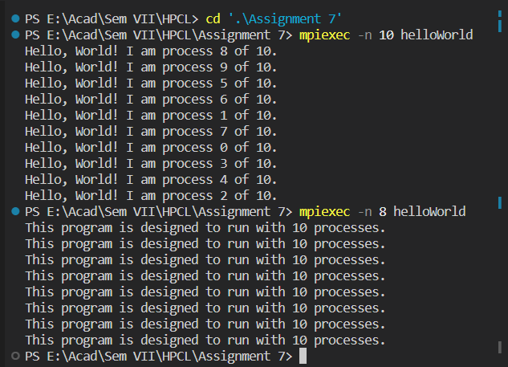

**Problem Statement 2:**

Implement a program to display rank and communicator group of five processes

**Screenshots:**

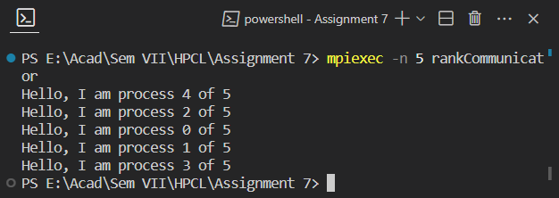

**GitHub:** [*https://github.com/meetgandhi692/HPC-Lab/tree/c2afb47464b5d2547f9217019268fdba36238abd/Assignment%207*](https://github.com/meetgandhi692/HPC-Lab/tree/c2afb47464b5d2547f9217019268fdba36238abd/Assignment%207)